**REPORT**

**QUERY #1**

**QUERY_ID: 6**

**Relevance Feedback**

|  |  |  |  |  |  |  |
| --- | --- | --- | --- | --- | --- | --- |
| **RELEVANCE FEEDBACK #** | **# OF RETERIEVED DOCS** | **PRECISION** | **RECALL** | **MAP** | **+ve docvs** | **-ve docs** |
| 1 | 50 | 0.180000 | 1.000000 | 0.854750 | 257 | 400 |
| 2 | 20 | 0.450000 | 1.000000 | 0.854750 | 268 370 | 39 78 |
| 3 | 50 | 0.180000 | 1.000000 | 0.854750 | 308 324 257 | 10 |
| 4 | 100 | 0.09000 | 1.0 | 0.854750 | 326 308 | 400 |
| 5 | 50 | 0.180000 | 1.0 | 0.854750 | 400 47 288 | 11 |

**Pseudo Relevance**

|  |  |  |  |  |
| --- | --- | --- | --- | --- |
| **RELEVANCE FEEDBACK #** | **# OF RETERIEVED DOCS** | **PRECISION** | **RECALL** | **MAP** |
| 1 | 50 | 0.060000 | 1.000000 | 1.000000 |
| 2 | 50 | 0.180000 | 1.0 | 0.909295 |
| 3 | 20 | 0.450000 | 1.0 | 0.909295 |
| 4 | 100 | 0.090000 | 1.0 | 0.909295 |
| 5 | 50 | 0.800000 | 0.444444 | 0.444444 |

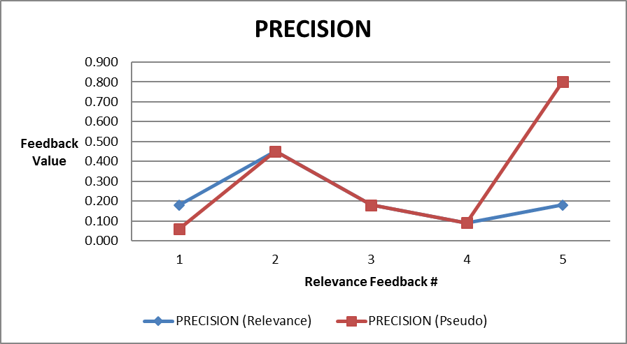

**For pseudo relevance the precision value is increasing with increase in the number of Rocchio iterations after a certain number of iterations.**

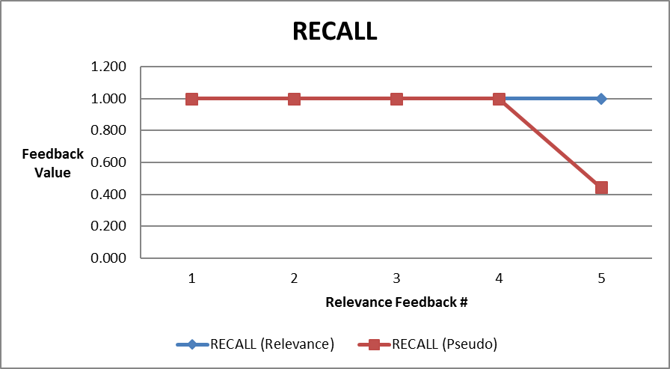

**The recall value of pseudo relevance in decreasing after the forth itereation.**

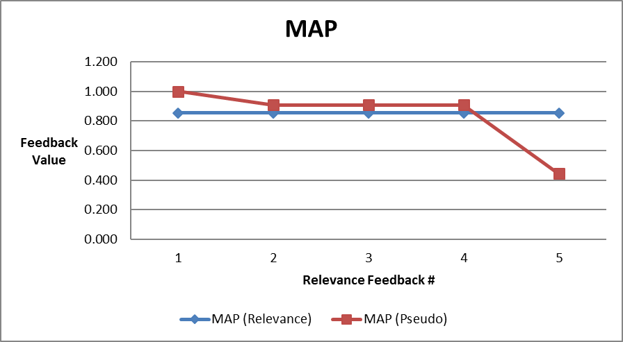

**The MAP values remain almost same after every iteration but decreases after the forth iteration.**

**QUERY #2**

**QUERY_ID: 12**

|  |  |  |  |  |  |  |
| --- | --- | --- | --- | --- | --- | --- |
| **RELEVANCE FEEDBACK #** | **# OF RETERIEVED DOCS** | **PRECISION** | **RECALL** | **MAP** | **+ve docs** | **-ve docs** |
| 1 | 20 | 0.350000 | 1.0 | 0.937925 | 156 | 89 |
| 2 | 20 | 0.350000 | 1.0 | 0.937925 | 61 90 159 | 360 |
| 3 | 50 | 0.140000 | 1.0 | 0.937925 | 12 | 78 |
| 4 | 100 | 0.070707 | 1.0 | 0.937925 | 56 232 | 100 |
| 5 | 50 | 0.070707 | 1.0 | 0.937925 | 204 65 39 | 400 |
|  |  |  |  |  |  |  |

**Pseudo Relevance**

|  |  |  |  |  |
| --- | --- | --- | --- | --- |
| **RELEVANCE FEEDBACK #** | **# OF RETERIEVED DOCS** | **PRECISION** | **RECALL** | **MAP** |
| 1 |  | 0.030303 | 1.0 | 1.0 |
| 2 | 50 | 0.140000 | 1.0 | 0.937925 |
| 3 | 20 | 0.350000 | 1.0 | 0.937925 |
| 4 | 100 | 0.070000 | 1.0 | 0.937925 |
| 5 | 200 | 0.035000 | 1.0 | 0.937925 |

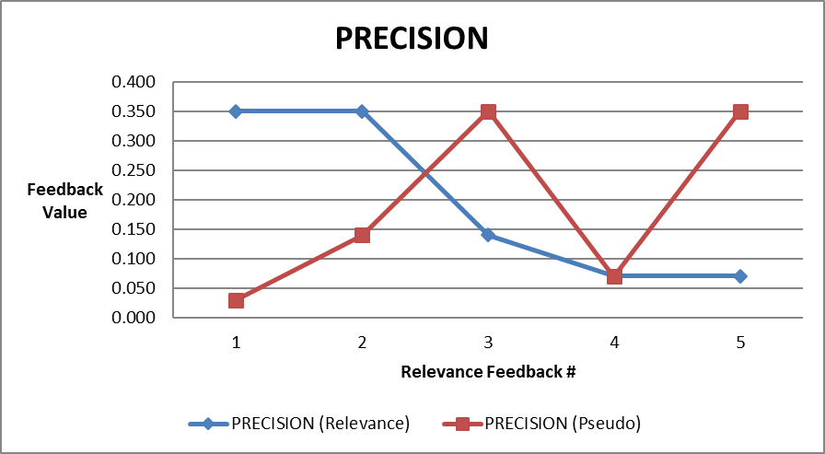

In this query the precision of the relevance feedback is decreasing as compared to the pseudo relevance feedback.

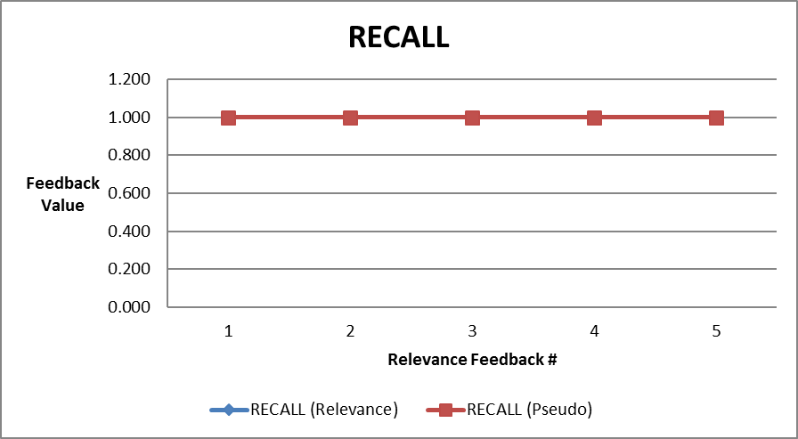

The recall value of both the methods are exactly same.

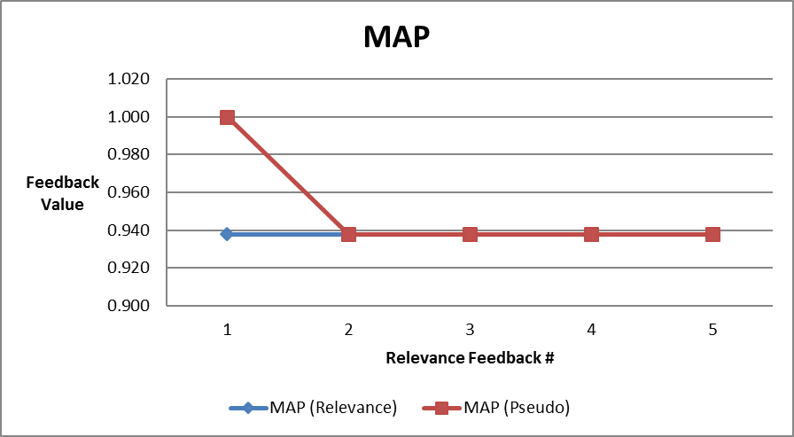

The MAP value is same for both the methods after the first iteration.

**QUERY #3**

**QUERY_ID: 77**

|  |  |  |  |  |  |  |
| --- | --- | --- | --- | --- | --- | --- |
| **RELEVANCE FEEDBACK #** | **# OF RETERIEVED DOCS** | **PRECISION** | **RECALL** | **MAP** | **+ve Docs** | **-ve Docs** |
| 1 | 100 | 0.010000 | 1.0 | 0.5 | 173 39 | 90 |
| 2 | 5 | 0.020000 | 1.0 | 0.5 | 303 65 260 | 400 202 |
| 3 | 10 | 0.025 | 1.0 | 0.5 | 223 | 65 |
| 4 | 20 | 0.014286 | 1.0 | 0.5 | 65 243 | 89 |
| 5 | 50 | 0.030000 | 1.0 | 1.0 | 53 78 12 | 43 |

**Pseudo Relevance**

|  |  |  |  |  |
| --- | --- | --- | --- | --- |
| **RELEVANCE FEEDBACK #** | **# OF RETERIEVED DOCS** | **PRECISION** | **RECALL** | **MAP** |
| 1 |  | 0.030000 | 1.0 | 1.0 |
| 2 | 20 | 0.050000 | 1.0 | 0.5 |
| 3 | 50 | 0.020000 | 1.0 | 0.5 |
| 4 | 100 | 0.010000 | 1.0 | 0.5 |
| 5 | 20 | 0.028571 | 1.0 | 0.5 |

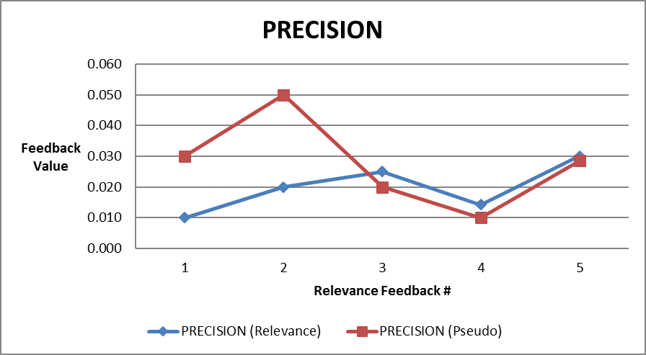

**The precision value for both the methods increase after the first iteration and decrease after the second iteration symmetrically.**



**Recall of both the methods are same for this query.**

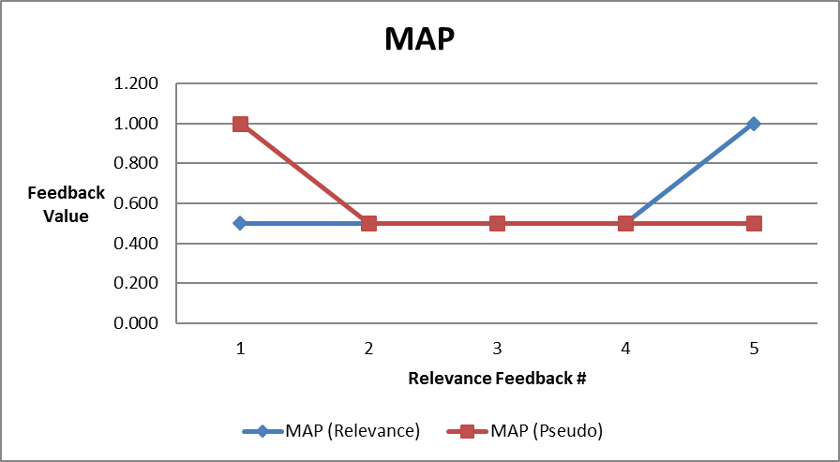

**MAP values remain same after the first iteration.**

**QUERY DRIFT:**